Lab 4: Storage Basics
Name: Amrish Kumar
Azure Region/Environment: East US (example)

Objectives
- Create Azure Storage Account
- Create Blob container & upload blob
- Generate and test SAS token
- Enable static website hosting & upload web content
- Understand LRS/ZRS/GRS tradeoffs
- Compare SAS tokens vs Access Keys

Step-by-step Actions Performed
- Created a Resource Group (if not already existing)
- Created a Storage Account (Standard, LRS, StorageV2)
- Verified Blob, Files, Queue, Tables available in menu
- Created a Blob Container named 'webassets'
- Uploaded a sample file to container
- Generated SAS token (Read/Write/List) and copied SAS URL
- Tested SAS in browser & via az CLI
- Enabled Static Website hosting and created $web container
- Uploaded index.html to $web container
- Accessed site via static website endpoint
- (Optional) Created File Share and Queue
CLI Commands used (paste below):
az group create --name lab4-rg --location eastus
az storage account create --name <storage_name> --resource-group lab4-rg --location eastus --sku Standard_LRS --kind StorageV2
az storage container create --name webassets --account-name <storage_name>
az storage blob upload --account-name <storage_name> --container-name webassets --file sample.txt --name sample.txt
az storage account generate-sas --permissions acdlrw --resource-types sco --services b --expiry 2025-12-31T23:59:00Z
az storage blob list --container-name webassets --account-name <storage_name> -o table

Screenshots
[Insert screenshot: Storage account overview]
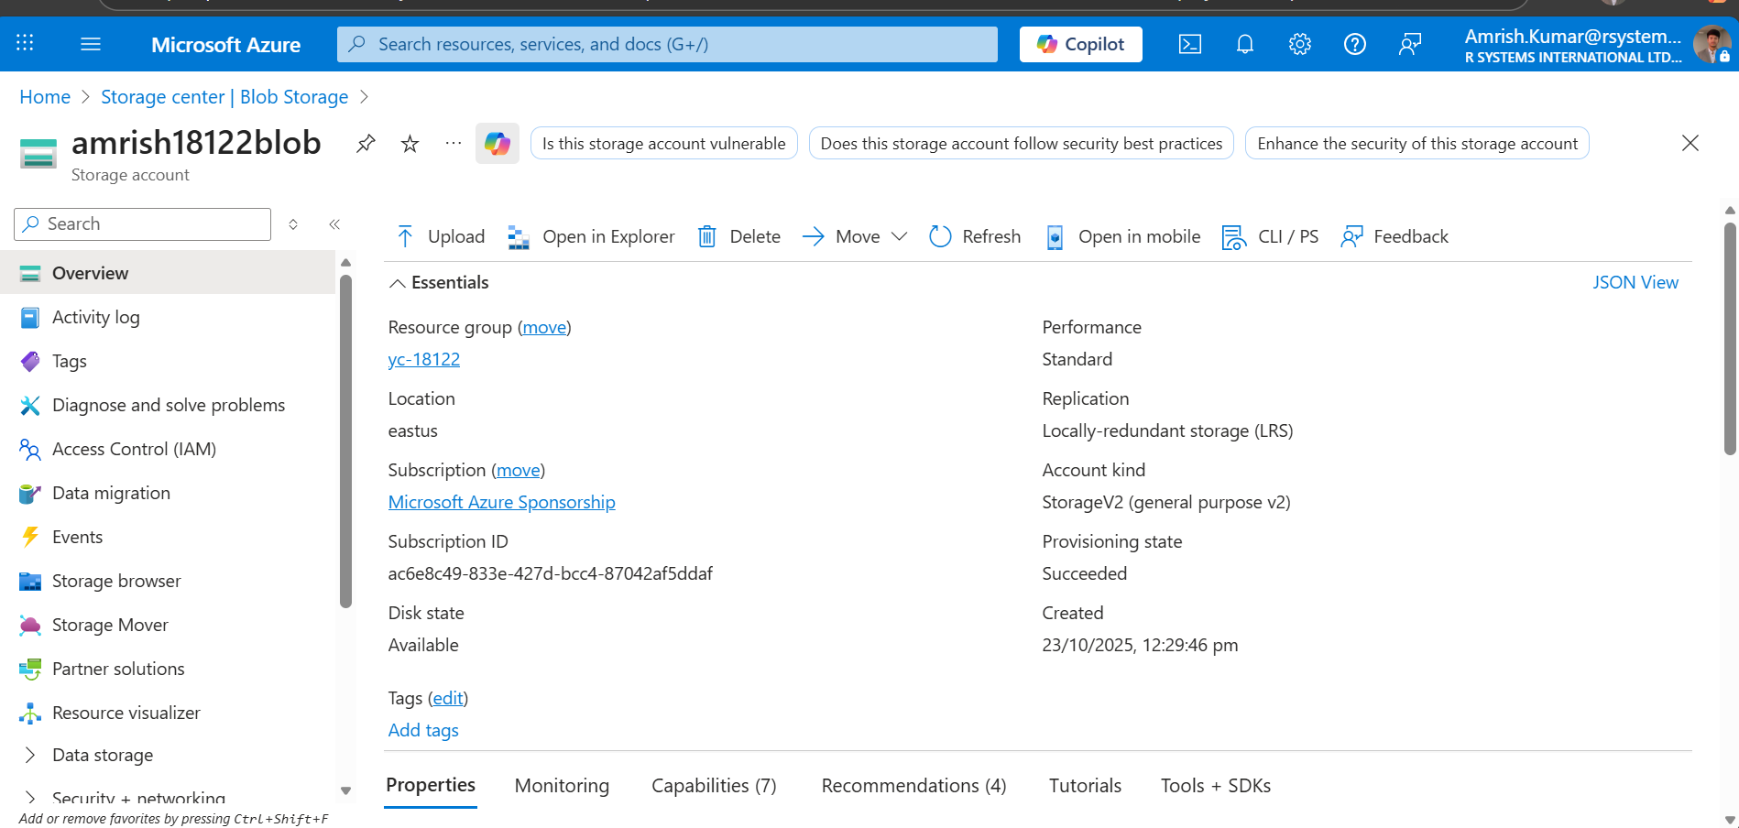
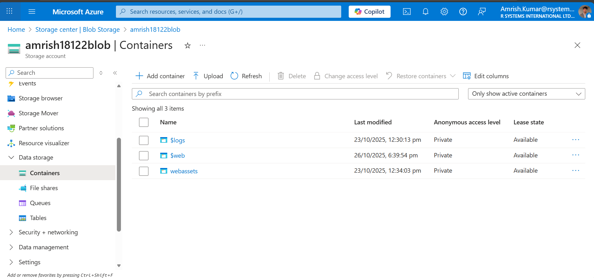
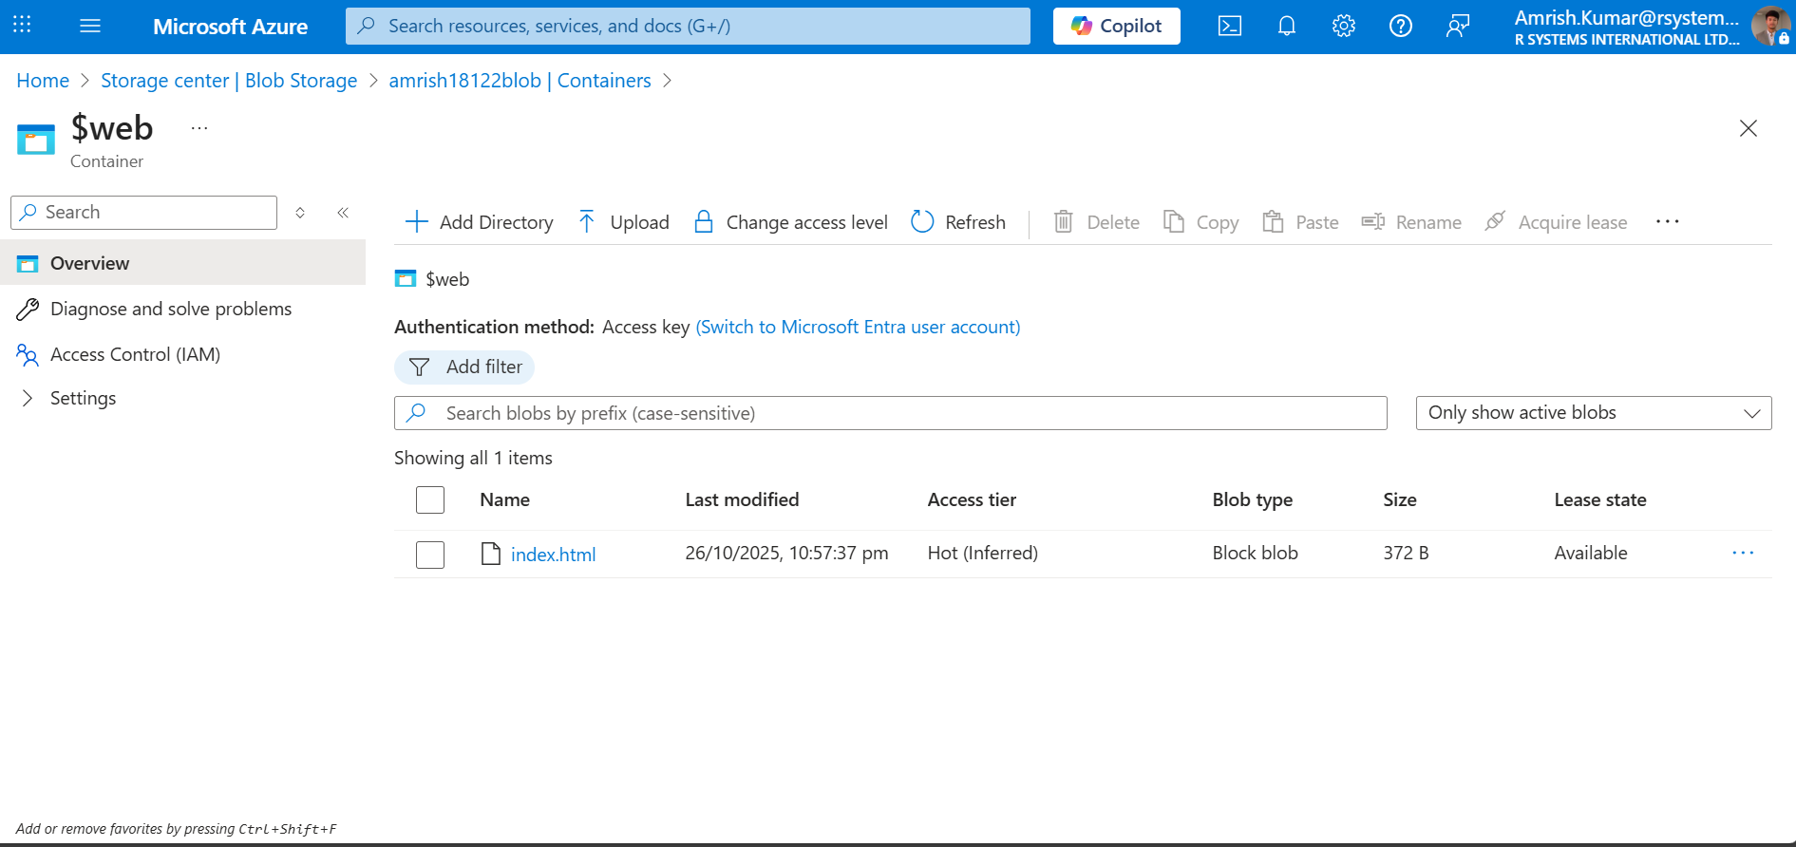
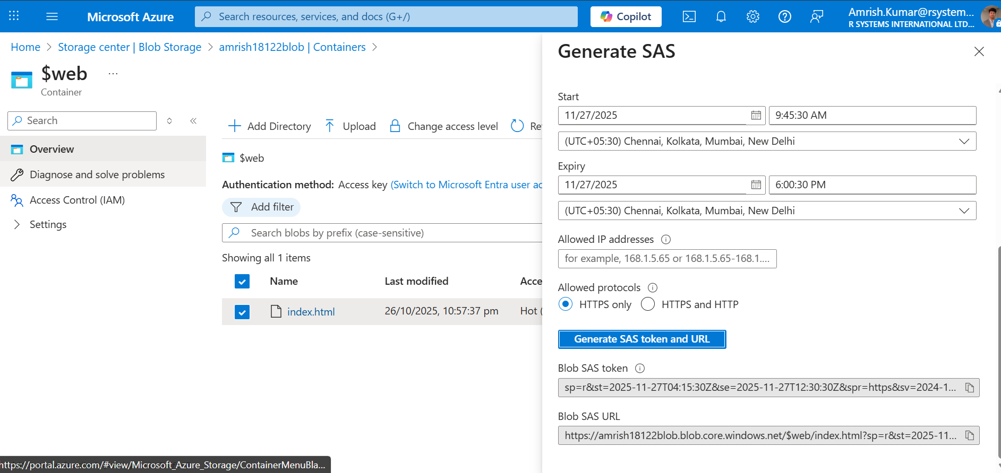
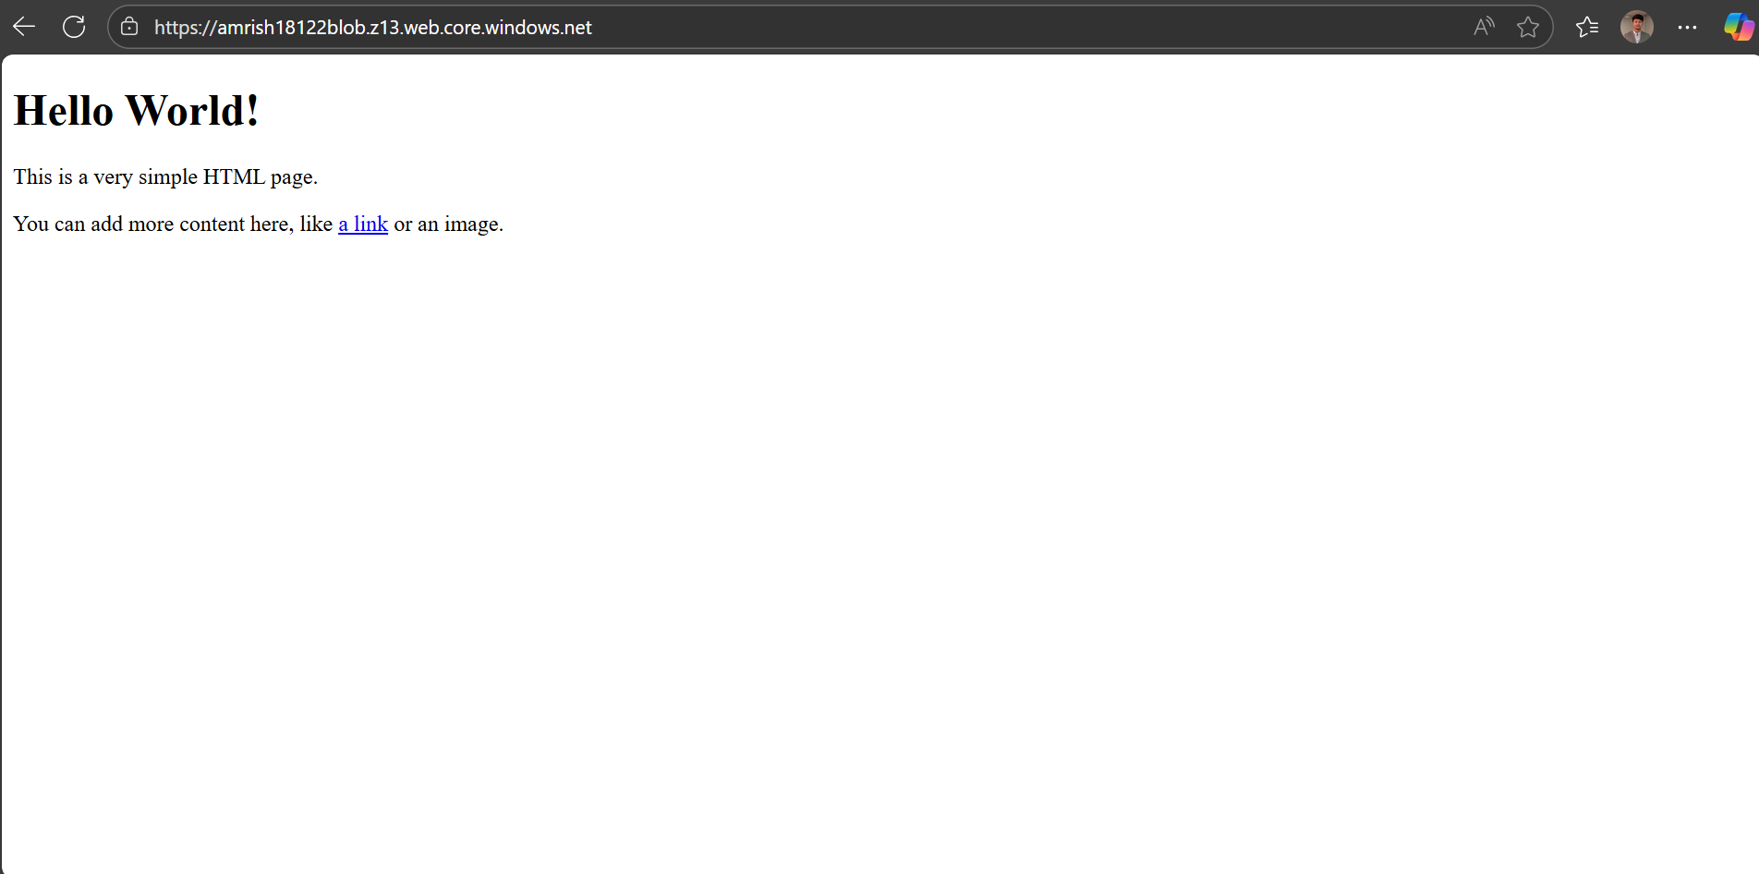
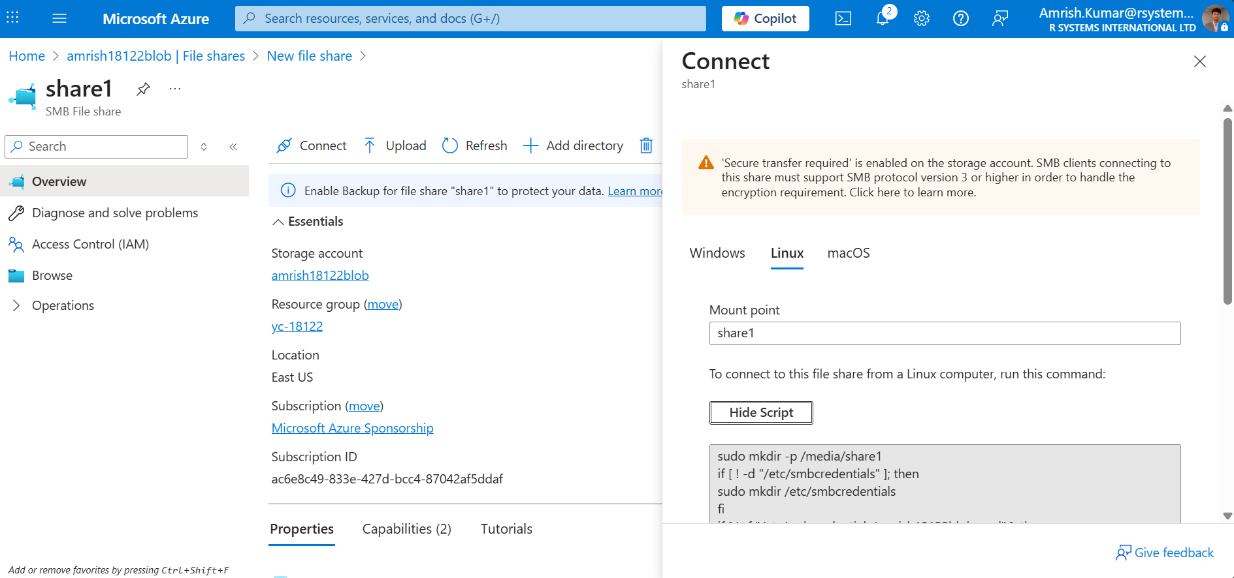

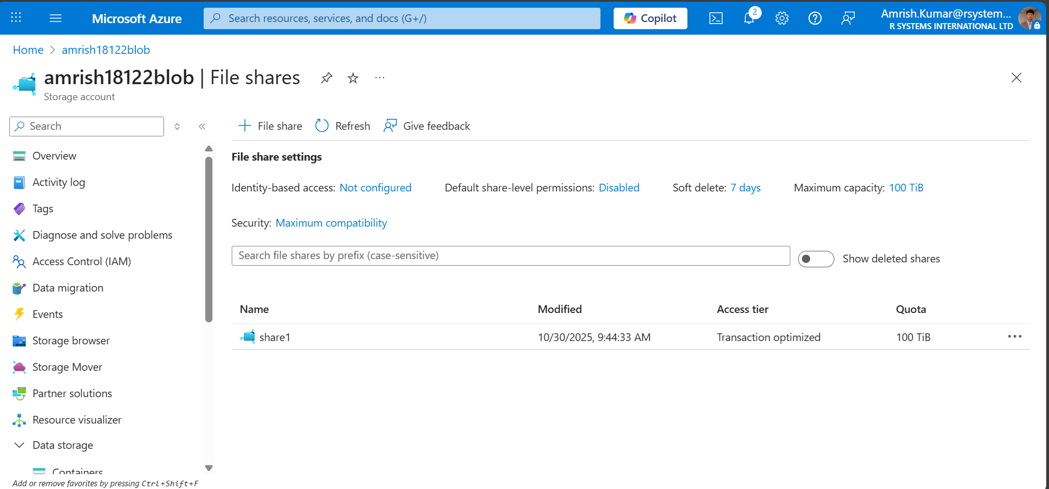
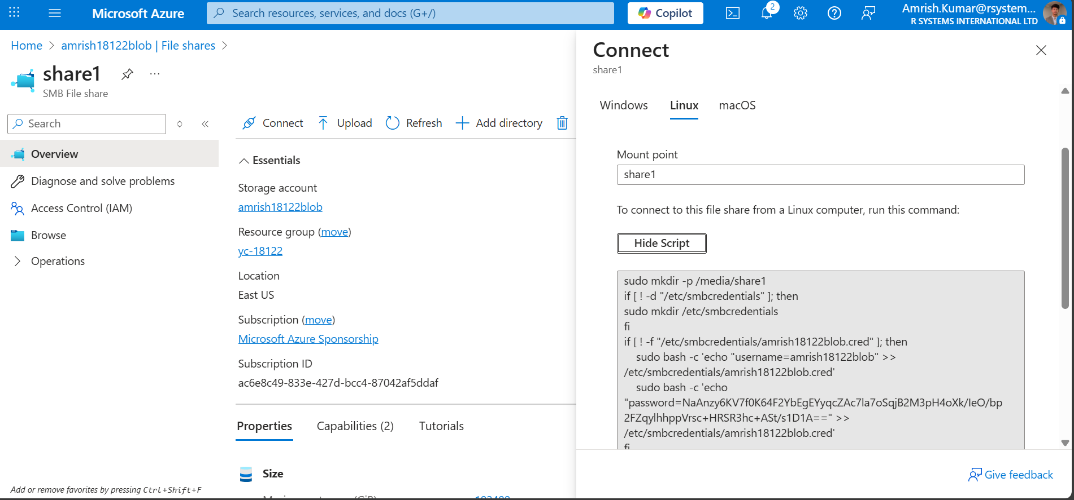

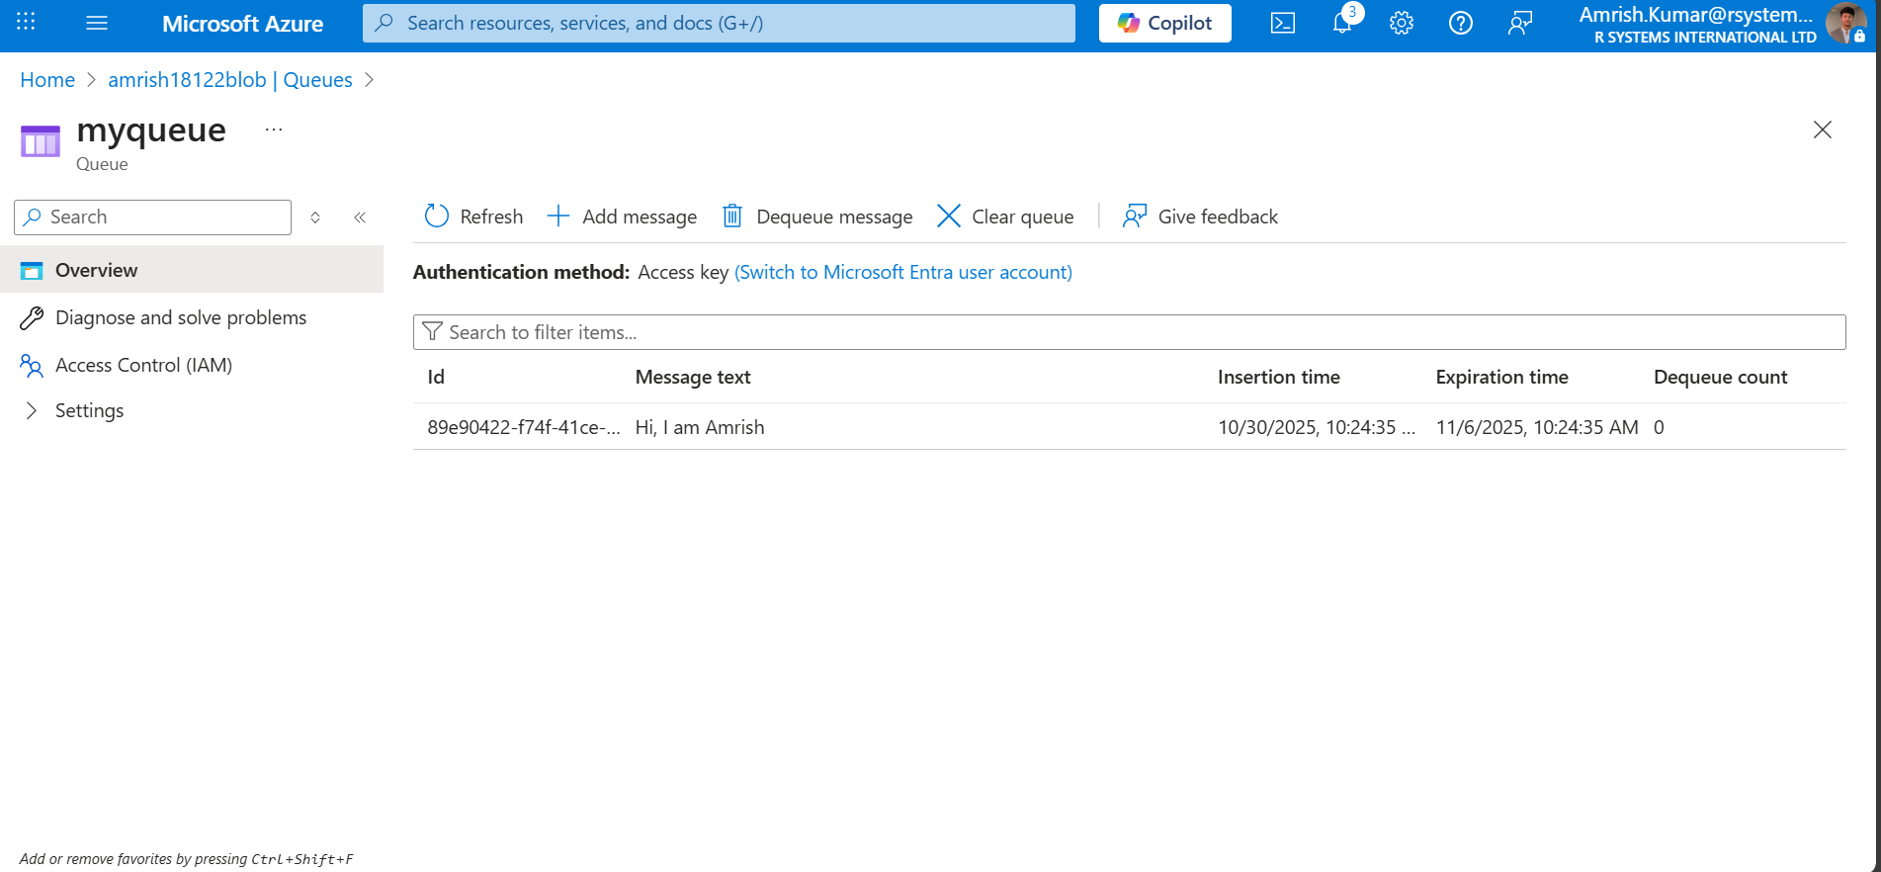

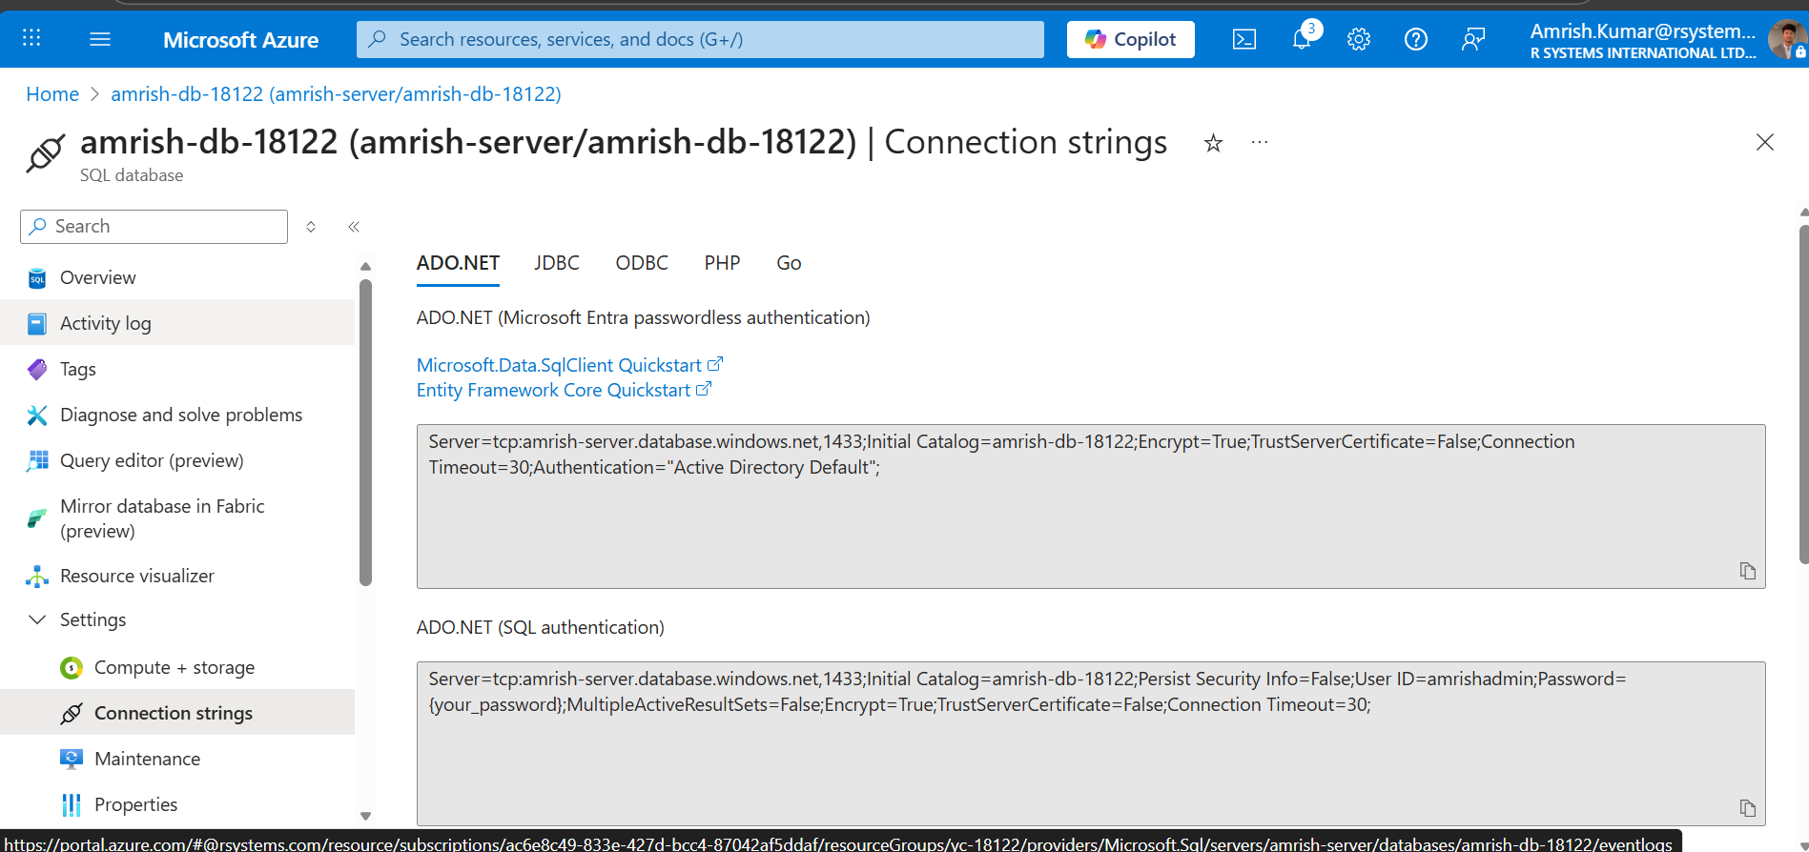

SAS Token Details
Example SAS Token (masked):
sv=2024-01-01&ss=b&srt=sco&sp=rwlac&se=2025-12-31T23:59Z&sig=***************
Permissions Used: Read, Write, List, Create, Add
Expiry Time: 24 hours

Replication Tradeoffs (LRS/ZRS/GRS/RA-GRS)
LRS - Locally Redundant Storage - copies data within single datacenter; cheapest; good for basic workloads
ZRS - Zone Redundant Storage - copies across 3 zones in region; higher durability; good for production apps
GRS - Geo Redundant Storage - replicates to secondary region; disaster recovery; asynchronous
RA-GRS - Read-access GRS - same as GRS but with read access to secondary; high availability DR

SAS vs Account Keys
SAS tokens allow granular, time‑limited permissions for secure external access.
Account keys provide full access to storage; should NOT be shared as they grant admin‑level privileges.
Use SAS for temporary or external access; keep account keys secret.

Observations & Issues
- SAS signature mismatch error occurred → fixed by regenerating key & reissuing SAS
- Static website required uploading index.html to $web container
- Browser SAS link showed XML access message when permissions incorrect

Cleanup Steps
az group delete --name lab4-rg --yes --no-wait

Appendix
Extra CLI output / logs:
N/A

